**First Czech company joins EIT Digital Accelerator**

**News 05/12/2019**

[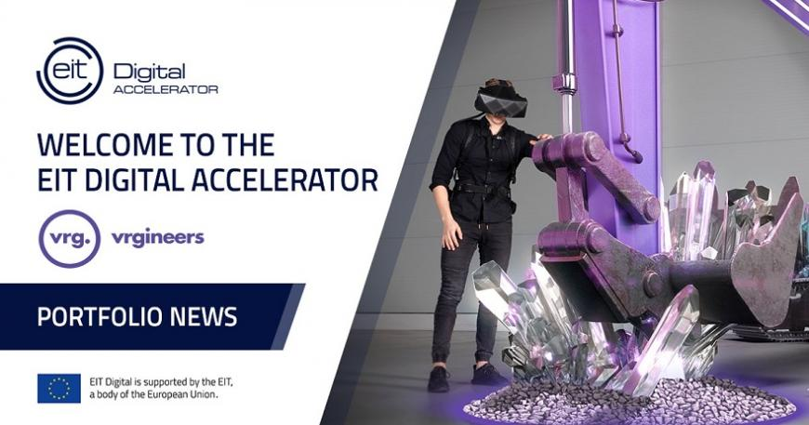](https://eit.europa.eu/sites/default/files/20191202_vrgineers_welcome_toaccel_banner.jpg)

**VRgineers, the first Czech Republic company, entered the EIT Digital Accelerator, the European support programme for deep-tech scale-ups.**

**World's leading virtual reality goggles**

[VRgineers](http://vrgineers.com/) has developed the [XTAL VR headset](https://vrgineers.com/xtal/), one of the world's leading virtual reality goggles. It is intended for prototyping in the automotive industry, design, remote administration of technical equipment or training.

Established two years ago, VRgineers’ technology is already being used at BMW, Volkswagen and Audi.

*We have the ambition to become a global leader in high-end virtual reality. We consider joining the EIT Digital network as another breakthrough moment that will direct us towards this goal.*

*Marek Polčák, CEO of VRgineers*

The [EIT Digital Accelerator](https://www.eitdigital.eu/accelerator) provides tailor-made growth support for European tech scale-ups by helping secure international customers and raise capital. The programme was recognised by the intelligence company UBI Global as a World Top Public Business Accelerator in the World Benchmark Study 2019 -2020 and ranked Top 4 Accelerator Brand in the Start-up Heatmap Report Europe.

*With our pan-European network of business developers operating from all across Europe, we will support VRgineers to grow especially in Germany, France, the UK and the US. Their cutting-edge VR gear for professionals has the potential to transform every industry. They have already proven their value various times in the automotive industry and are now targeting more segments including aviation & aerospace, defence, oil & energy, transportation, e-commerce, industrial design and mechanical engineering or real estate.*

*Paolo Magni, Business Developer at EIT Digital Accelerator*

'EIT Digital is an international network that focuses on fostering innovation, education and entrepreneurship in digital technology. It provides companies with fast and efficient access to a pan-European business network and offers them the opportunity to connect with international customers and investors,' says Monika Vrbková from the [JIC](https://www.jic.cz/) innovation agency, the official partner of EIT Digital for the Czech Republic.

**About Vrgineers**

[VRgineers, Inc.](http://www.vrgineers.com) is a virtual reality engineering company developing and manufacturing cutting-edge enterprise-grade VR gear for professionals. Its new generation high-resolution VR headset platform is used by clients in the automotive, architecture, industrial design, and training sectors, enabling them to transform their work using VR technology. The company is headquartered in Prague with a U.S. office in Los Angeles.

**About JIC (South Moravian Innovation Centre)**

[JIC](http://www.jic.cz) empowers people to create businesses that can change the world. It envisions an open innovation ecosystem – home to globally successful entrepreneurs and an inspiration for the world. JIC supports, guides, inspires and teaches, it believes that only people who see their work or business as meaningful can be simultaneously successful and enjoy satisfying lives. About one hundred South Moravian companies come through its programmes each year, from start-up entrepreneurs driven by a new idea to established firms. With this throughput, JIC has contributed to creating one of the most innovative entrepreneurial systems in Central Europe. Since it was established in 2003, there have been more than 300 companies (with combined revenues amounting to CZK 30 billion and almost 6,500 employees) supported by JIC.